Data Structures and Algorithms I
Spring 2009
Homework #3

(1) In class, we have learned that all comparison based sorts require at least Ω(N log N) comparisons, and therefore time, in the worst and average case. Quicksort, which has an average running time that is Θ(N log N) and a worst case running time that is Θ (N²) for typical implementations, is said by our textbook to be "the fastest known generic sorting algorithm in practice". However, we later learned about least-significant-digit radix sort, a linear sort that is not covered in our textbook. This is not a discrepancy with what we have said previously, because this version or radix sort is not a comparison based sort, and it is also not generic, because it can not be used to sort all types of values. These questions deal with quicksort and radix sort.

- After discussing the guaranteed linear solution to the selection problem, it was mentioned that using median-of-five partitioning (what our textbook calls median-of-median-of-five partitioning) as a pivot selection routine could lead to a quicksort that is Θ(N log N) in the worst case. Explain why this is not commonly used in practice.
- Explain why radix sort is not usable for sequences of any data type.
- Explain why quicksort might often be faster than radix sort for reasonably large sequences in practice.
- Assuming that we are sorting integers, and that memory is not an issue, is it necessarily true that radix sort will be faster than quicksort for sequences that are longer than some specific finite size? Explain your answer.

(2) Answer the following questions about sorts we have discussed in class.

- First explain a realistic situation for which it would be necessary to use a stable sort. Then state which of the following sorts that we have covered in class are stable (assuming typical implementations of each of the sorts): bubble sort, selection sort, insertion sort, Shellsort, mergesort, quicksort, radix sort.
- Explain two types of situations in which it might be useful to use an indirect sort.
- We have learned that implementations of bubble sort and insertion sort both typically require a linear number of passes, and that each pass typically requires a linear amount of time, when sorting arbitrary data. We have also learned that good implementations of both of these sorts should run very fast when applied to sequences that are almost sorted to begin with. However, the reasons why this is true for each of these sorts are different. Explain why each of these sorts is fast when applied to an almost sorted sequence.
- Explain conceptually why quicksort tends to run faster than mergesort in practice.
(3) Consider the following AVL tree:

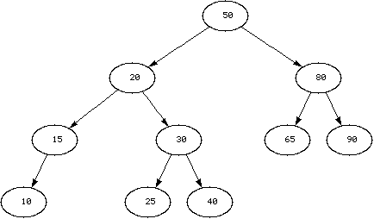

Parts (a) through (d) of this question should be considered independently of each other.

- Draw the resulting AVL tree when the value 12 is inserted into the shown tree.
- Draw the resulting AVL tree when the value 7 is inserted into the shown tree.
- Draw the resulting AVL tree when the value 99 is inserted into the shown tree.
- Draw the resulting AVL tree when the value 42 is inserted into the shown tree.

(4) For each of these questions, you will be making N insertions into a data structure that initially either contains k items or is empty. Assume that k >> N (i.e., k is much larger than N). Assume that the data structures all have good implementations. Express using big-Theta notation the total expected run time and the total worst case run time of the N insertions (not the run times of each individual insertion) in terms of N and k.

- N pushes onto a stack that starts off empty.
- N pushes onto a stack that initially contains k items.
- N insertions into a regular binary search tree that starts off empty.
- N insertions into a regular binary search tree that initially contains k items.
- N insertions into an AVL tree that starts off empty.
- N insertions into an AVL tree that initially contains k items.

