Data Structures and Algorithms I
Spring 2008
Homework #3

(1) Consider the following array of unsigned, 16-bit integers:

{59323, 6550, 29140, 31397, 52989, 17165, 20106, 57118}

(a) Show the binary representation of each of these values.

(b) If you want to use radix sort to sort this array with 4 passes, how many buckets are necessary?

(c) Using this number of buckets, show what the array looks like after each pass. (List the numbers in decimal, not binary, in the order that they would appear after each pass.)

(2) Assume that the following sequence is inserted into an initially empty, ordinary binary search tree (not an AVL tree):

17, 29, 22, 90, 75, 13, 80, 81, 55, 62, 40, 33, 31, 21, 76

(a) Draw a picture of the resulting binary search tree.

(b) If the resulting tree from part (a) is traversed using a preorder traversal, in what order will the nodes be visited?

(c) If the resulting tree from part (a) is traversed using a postorder traversal, in what order will the nodes be visited?

(d) If the resulting tree from part (a) is traversed using an inorder traversal, in what order will the nodes be visited?

(3) Briefly answer the following questions about sorts:

(a) Explain why a good implementation of insertion sort is very fast for sequences that are close to sorted.

(b) Name two advantages of merge sort over quicksort.

(c) Intuitively explain why quicksort is generally faster than merge sort.

(d) Explain two types of situations in which it might be useful to use an indirect sort.

(e) We have discussed a proof that all comparison based sorts require at least Ω(N log N) running time in the average case. Explain then how it is possible that radix sort can be linear in the worst case.

(4) Consider the following array, which is to be sorted using quicksort with median-of-three partitioning (not the more complex median-of-five partitioning):

{82, 20, 26, 45, 91, 30, 79, 21, 48, 72, 64, 51, 7, 85, 66}

(a) Assume that the partition function calls a medianOfThree function that sorts the three appropriate elements in place and returns the index of the pivot but does not do anything else. (This follows the pseudo-code discussed in class, but is different than the book’s implementation.) What does the array look like right after medianOfThree returns?

(b) With other pivot selection strategies, the pivot is swapped with the last element of the array, but when medianOfThree is used for pivot selection, the pivot is swapped with the second to last element of the array instead. Why do we change the algorithm like this when median-of-three partitioning is used?

(c) Show what the array looks like after the pivot is swapped with the second to last element.

(d) Show what the array looks like at the end of the partition function.

(5) Consider the following AVL tree:

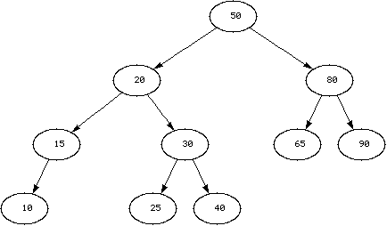

Parts (a) through (d) of this question should be considered independently of each other.

(a) Draw the resulting AVL tree when the value 5 is inserted into the shown tree.

(b) Draw the resulting AVL tree when the value 70 is inserted into the shown tree.

(c) Draw the resulting AVL tree when the value 35 is inserted into the shown tree.

(d) Draw the resulting AVL tree when the value 12 is inserted into the shown tree.

