Data Structures and Algorithms II
Fall 2007
Programming Assignment #3

You are going implement Dijkstra's algorithm to solve the single-source shortest-path problem. The program will determine the shortest path in a specified graph from a specified starting vertex to each other vertex in the graph. In order to do this efficiently, your program should use the binary heap class that you created for the previous assignment.

Your program should start by asking the user to enter the name of a file specifying the graph. The first row of the file will specify the maximum number of vertices. If this number is N, all vertices will have an id ranging from 1 to N. It is possible that not every vertex in this range will exist in the graph. Each remaining row of the file specifies an edge in the graph. Each such row contains three integers. The first two integers represent the source vertex and destination vertex of the edge (i.e., they are integers in the range from 1 to N). The third integer represents the cost (i.e., distance or weight) of the edge. All edge costs will be positive integers less than one million. A vertex exists if it is the source or the destination of any edge. Each edge will exist at most once in the file, and the source vertex will never be the same as the destination vertex. Your program may assume that the file, if it can be opened, is valid. You are not required to include error checks for invalid file formats; you may if you wish, but I will not check for this.

Once the program is finished reading in the graph, the user should be prompted to enter the id of a starting vertex. The user should be re-prompted until they enter a valid index (i.e., an integer in the appropriate range indicating a vertex that exists in the graph). The program should then apply Dijkstra's algorithm to determine the shortest path to each node from the specified starting vertex. The implementation should rely on the binary heap class that you created for the previous assignment. When the algorithm has finished determining the shortest path to each node, your program should output the CPU time, in seconds, that was spent executing the algorithm.

The program should then ask the user for the name of an output file. The output file should contain one row for every vertex that exists in the graph. Indices in the appropriate range that do not represent existing vertices should not have corresponding rows in the output file. Each row in the output file should contain a vertex id followed by a colon, a single space, and then the shortest distance from the specified starting vertex to the given vertex. All of these distances are guaranteed to be less than one billion. After the distance, the row should contain one space, a left bracket, the path from the starting vertex to the current vertex, a right bracket, and finally a newline character. Vertices in the path should be separated by a comma followed by a single space. There should not be any space or comma before the first vertex in the path (the specified starting vertex) or after the last vertex in the path (the id of the current vertex). If there is no path from the specified starting vertex to the current vertex, the output row should contain the vertex id followed by a colon, a single space, and then the text "NO PATH" followed by a newline character. You must follow these instructions exactly.
In class, we stepped through Dijkstra's algorithm for the following graph, which came from Figure 9.20 in the textbook:

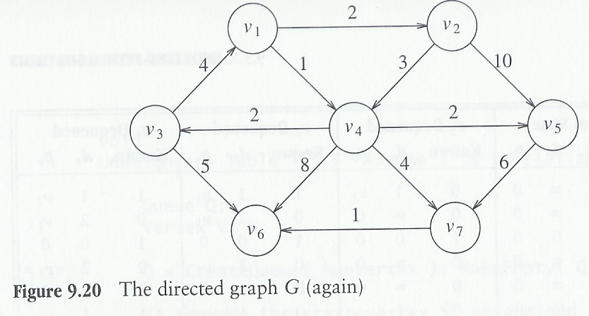

If the vertices v₁ through v₇ are assigned id numbers 1 through 7 respectively, the file representing this graph might look like this:

7
1 2 2
1 4 1
2 4 3
2 5 10
3 1 4
3 6 5
4 3 2
4 5 2
4 6 8
4 7 4
5 7 6
7 6 1

Any permutation of the rows representing edges in this file would designate the same graph. Assume a file called graph.txt exists, containing the data shown above (or equivalent data). Then a sample run of your program might look like this:

Enter name of graph file: graph.txt
Enter a valid vertex id for the staring vertex: 1
Total time (in seconds) to apply Dijkstra's algorithm: 0.000
Enter name of output file: out.txt

The prompts to the user may vary, but the file out.txt should look exactly like this:

1: 0 [1]
2: 2 [1, 2]
3: 3 [1, 4, 3]
4: 1 [1, 4]
5: 3 [1, 4, 5]
6: 6 [1, 4, 7, 6]
7: 5 [1, 4, 7]
If the user specified the same graph file but entered 5 as the id of the starting vertex, then the output file should look exactly like this:

1: NO PATH
2: NO PATH
3: NO PATH
4: NO PATH
5: 0 [5]
6: 7 [5, 7, 6]
7: 6 [5, 7]

Remember, if a vertex does not exist, there should be no corresponding row for that potential id in the output file. For example, if the number at the start of the input file is 10, then the valid vertex id numbers are 1 through 10; but if, for example, only 2, 4, 7, and 9 exist (i.e., these are the only id numbers that show up in edges), the output file should contain only four rows.

To give you an idea of expected speed, when I ran the C version of my program (I haven't updated it to C++ yet) on my previous home computer using cygwin, specifying a randomly generated file representing a graph including four million edges involving just under one million vertices (one million were possible, but some were missing), my implementation of Dijkstra's algorithm required about 6.4 seconds. (Reading the input file and writing the output file actually takes a bit longer than that, but the time for input and output is still totally reasonable.)

After you have completed the assignment, e-mail me (CarlSable.Cooper@gmail.com) your code, including a Makefile. You should not need to e-mail me either heap.cpp or heap.h, however, unless you change them. I will copy your versions of these files into a directory with your code for this assignment and run "make". Furthermore, you should not re-implement any of the binary heap functionality in your new code in order to avoid using routines that do not work for this application. If you needed to change your binary heap files, then send them to me as well, but you will lose up to 15 points depending on the extent of the changes. Minor changes will lose just a few points, and if the changes fix bugs for which I have already taking off points on the previous assignment, you will not lose points a second time (so be sure to indicate this in comments above the changed code). If you never get your binary heap class working at all, I can send you my compiled object file to use, but then you will definitely lose the full 15 points, even though you would have also obviously lost points on the previous assignment. The program is due by midnight on the night of Wednesday, November 14.

