Programming Languages
Spring 2004
Midterm Solutions

(1) Answer the following questions about internal representation of integers: (15 points)

(a) If a system uses 16 bit signed integers, using two's complement to represent negative numbers, what will be the representation of the integers 999, -1, and -170? (10 points)

999₁₀ ➔ 0000001111100111₂
-1₁₀ ➔ 1111111111111111₂
-170₁₀ ➔ 1111111101010110₂

(b) If a system uses 24 bit signed integers, what is the largest positive integer that can be represented to the nearest power of 10? (5 points)

The largest positive integer would be approximately 2²³ = 2¹⁰ * 2¹⁰ * 2³ which is approximately 1000 * 1000 * 8 = 8 million.
(2) Answer the following short answer questions about parts of memory: (15 points)

(a) Describe the three main sections of memory used by an executing program. What is stored in each? (5 points)

Static memory stores the program code and globals.

The stack stores activation records for active procedures.

The heap stores dynamically allocated memory.

(b) Describe the three parts of an activation record. What is stored in each? (5 points)

The first part stores values of passed parameters and optionally a return value.

The second part stores machine status information (e.g. the return address and values of registers that need to be restored).

The third part stores temps and local variables (temps are variables in the machine code that are not in the high-level code).

(c) Why isn't common to store activation records in static memory (i.e. to store the activation record for a specific function in the same place every time the function is called)? (5 points)

Most importantly, this makes it very difficult for a language to allow general recursion since there will only be one activation record for each function. Also, if there are many functions in a large program with only a few active functions at a time, it would take up more memory.
(3) Answer the following question about binary trees: (20 points)

(a) Draw a binary tree, using the regular ordering scheme, assuming that the following numbers are inserted, in this order, into an initially empty binary tree: (10 points)

100, 200, 25, 50, 70, 150, 300, 100, 100, 99

100
200
25
50
70
99
300
150
100
100

(b) Consider the following binary tree in which values were not inserted using the ordinary scheme: (10 points)

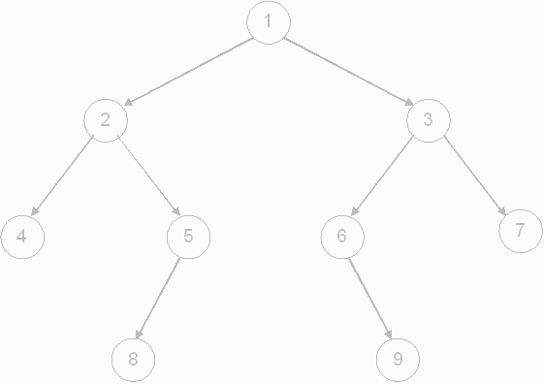

In what order would an ordinary inorder traversal of the tree visit the values?

4, 2, 8, 5, 1, 6, 9, 3, 7
(4) What would the following program display to standard output? (20 points)

#include <stdio.h>

int do_stuff(int, int *, int *, int);

int a = 5;

int main(void) {
int b = 10, c = 15, d = 20, e = 25, f;

f = do_stuff(b, &c, &d, a);

printf("%d, %d, %d, %d, %d, %d\n", a, b, c, d, e, f);

return 0;
}

int do_stuff(int b, int *p1, int *p2, int x) {
int e;

e = 30;
a = 35;
x = 40;
*p1 = 45;
b = 50;
p2 = &b;
*p2 = 55;

return b;
}

35, 10, 45, 20, 25, 55
(5) Assume you are writing a program that uses linked lists of characters to representing strings! The following is the definition of a node structure: (30 points)

typedef struct node {
char c;
struct node *next;
} NODE;

typedef NODE *PNODE;

(a) Write a create_node function that accepts a character as a parameter, allocates memory for a node, initializes the appropriate field of the structure to the passed character, and initializes the next field to NULL. If there is not enough memory available, the function should display an error message and exit (so other functions can assume that if this function returns, memory was allocated correctly). The function should return a pointer to the new node. (5 points)

PNODE create_node(char c) {
PNODE pTemp;

pTemp = (PNODE) malloc(sizeof(NODE));

if (pTemp == NULL) {
printf("Error: Out of memory!\n");
exit(1);
}

pTemp->c = c;
pTemp->next = NULL;

return pTemp;
}

(b) Write a convert_string function that accepts a standard C string as a parameter and converts the string to a linked list! The null character should not be a part of the linked list. The program should return a pointer to the start of the created list. HINTS: Loop through the characters of the string one at a time from left to write. For each character, call your create_node function from part (a) and add the node it creates to the end of the list so far. Keep track of pointers to the start of the linked list and the end of the linked list. If the pointer to the current start of the list is NULL, this means the current character is the first character, and the new node represents the entire list so far. Otherwise, the last node of the list so far should point to the new node, and then the pointer to the last node should be updated to point to the new final node. (15 points)

PNODE convert_string(char *str) {
PNODE pTemp, pStart = NULL, pEnd = NULL;
char *pc;

for (pc = str; *pc != '\0'; pc++) {
pTemp = create_node(*pc);

if (pStart == NULL) {
pStart = pEnd = pTemp;
}
else {
pEnd->next = pTemp;
pEnd = pTemp;
}
}

return pStart;
}

(c) Write a display_string function that accepts a pointer to the start of a linked list representing a string and displays the string to standard output followed by a newline character. The function should not return any value. (10 points)

void display_string(PNODE pList) {
while(pList != NULL) {
putchar(pList->c);
pList = pList->next;
}

putchar('\n');

return;
}

